## horizontal line

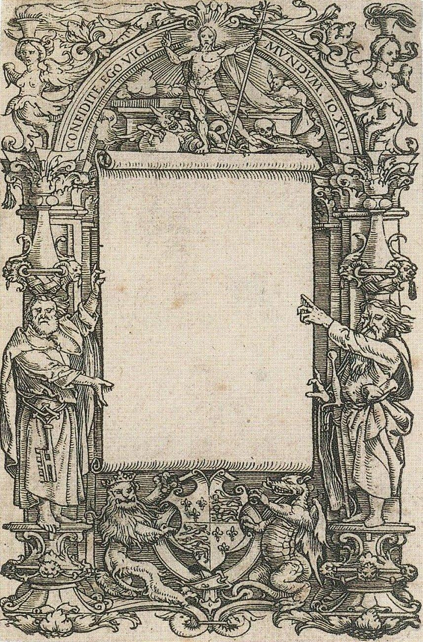

Team ENIAC

23.07.2019

**─**

Fazle Rabbi Rakib Md. Habibur Rahman

2nd year, 2nd semester 2nd year, 2nd semester

Department of Software Engineering,SUST Department of Software Engineering,SUST

[fazlerakib009@gmail.com](mailto:fazlerakib009@gmail.com) habib11wahid@gmail.com

# 

**(Idea 2) PROJECT :E-Provost**

* **Problem :** Most of the students stays in hall in university. So it’s very natural to face problems in the halls. But the way to solve the problem is traditional.
  + Students write to a notebook in the provost room.So when sir watch the book then he can know about the problem.
  + Most of the time provost sir does not visit hall regularly. So students fall in great problem. So we want to develop a system to handle this problem of hall students.
* **System Features**:
  + The system will require an account of student.
  + Students can share their problems in an interface.
  + Hall provost will also require an id and can directly notice the problem in the system interface.
  + Provost can update all the notifications about hall and So students can easily access the notifications.
* Interfaces:

Students Interface: Provost Interface

Log In requirement 1.Name

1.Student’s name 2.Title

2.Department

3.Versity Roll

4.Hall Name

5.Hall Id Number

Problem Interface

1. There will be an interface which will show all the problem updated by the students.
2. There will be a red icon which will be green if provost solve the problem.